Contents

**Batch size 4 – With out LR Schedule** 2

**Batch size 8: LR rate = 0.001** 3

**Batch size 8: LR rate = 0.0001** 4

**Batch size 4: LR rate = 0.01** 6

**Batch size 4: LR rate = 0.0001** 7

**Batch size 4: LR rate = 0.001** 8

**Batch size 16 - Learning Rate = 0.01 ,0.001 , 0.0001** 9

# **Batch size 4 – With out LR Schedule**

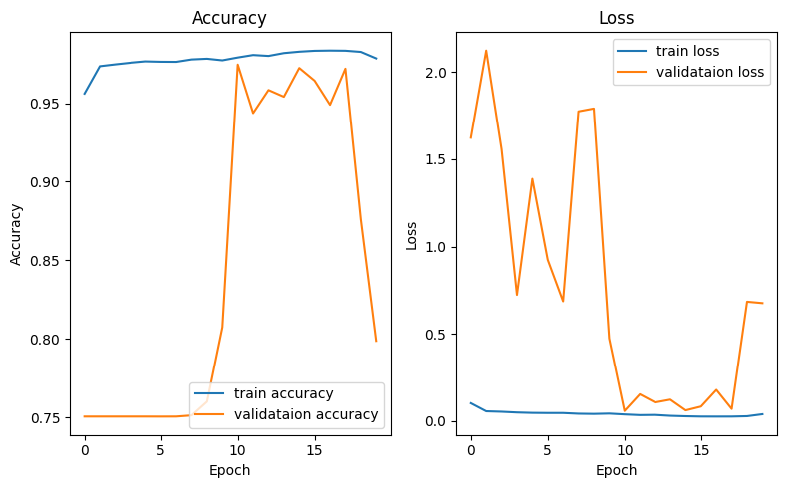

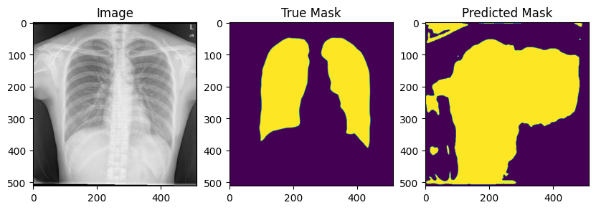

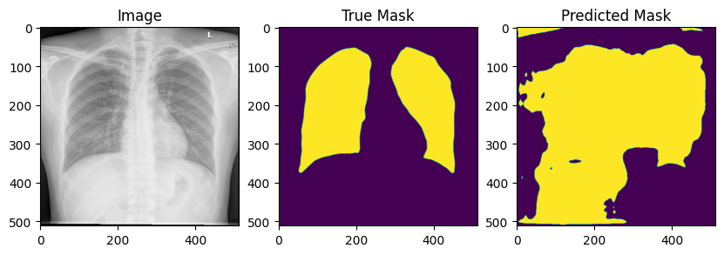

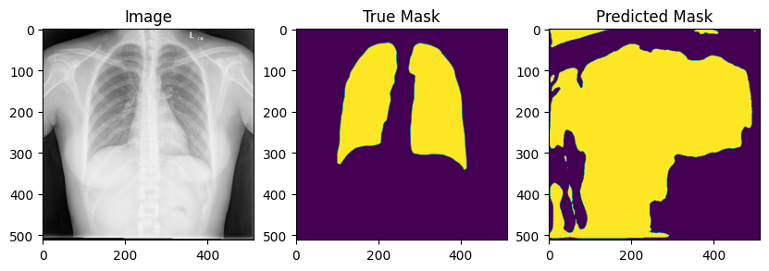

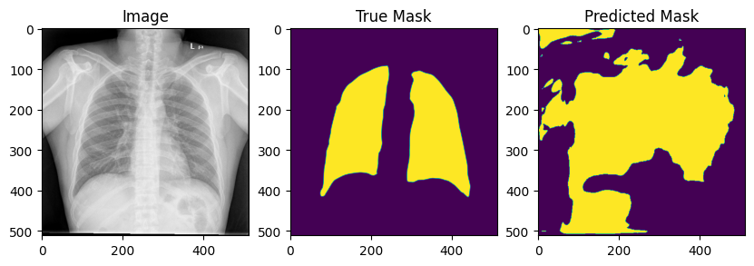

# **Batch size 8: LR rate = 0.001**

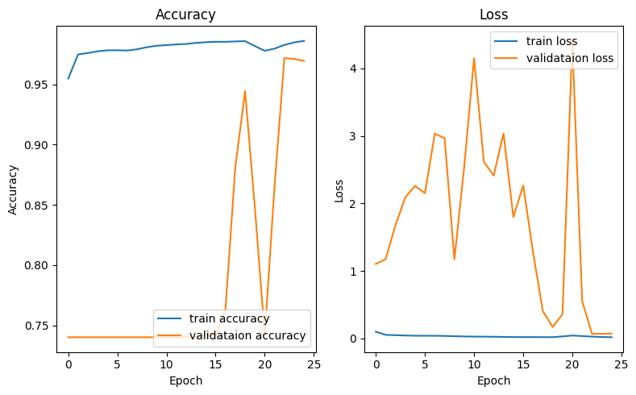

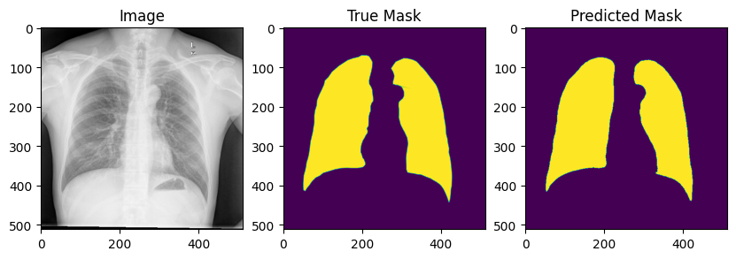

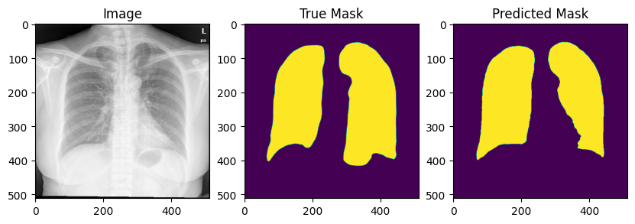

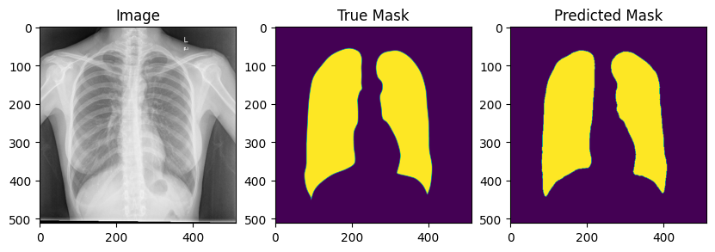

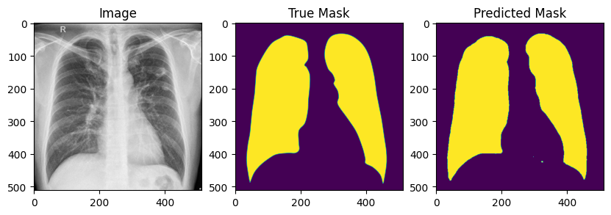

# **Batch size 8: LR rate = 0.0001**

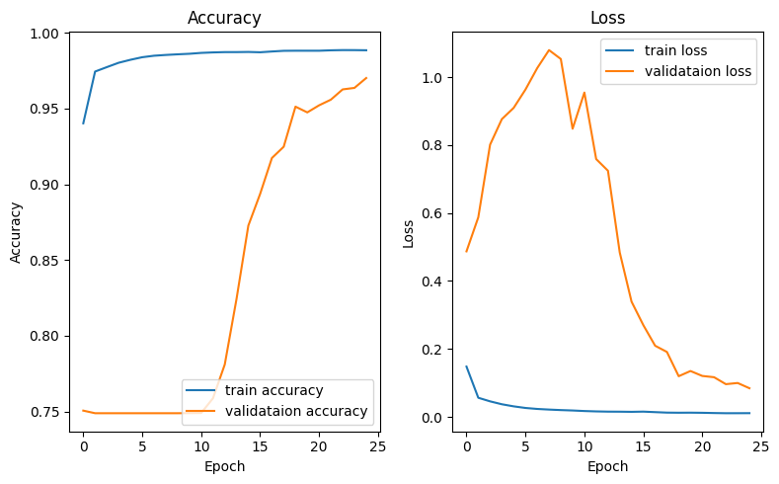

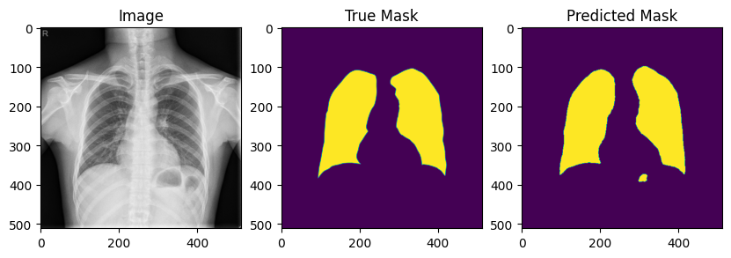

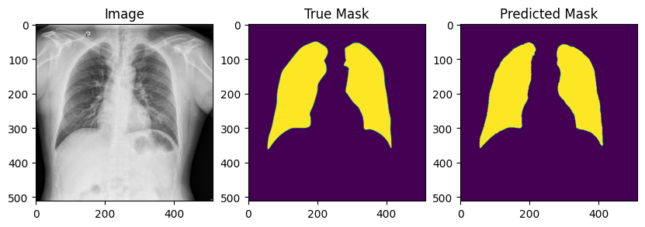

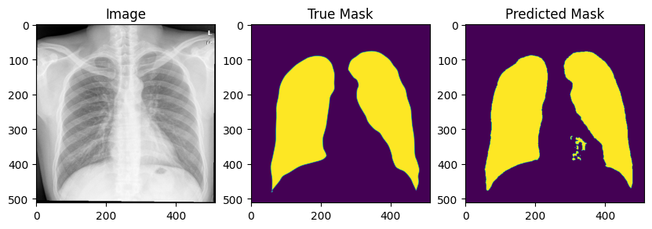

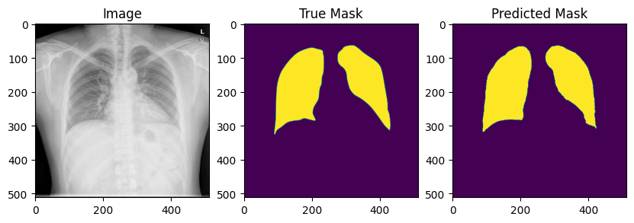

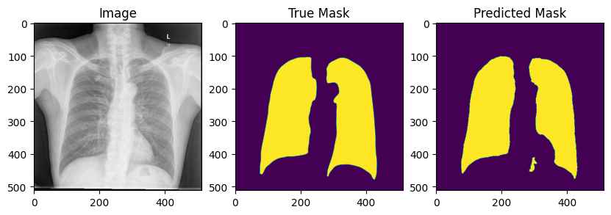

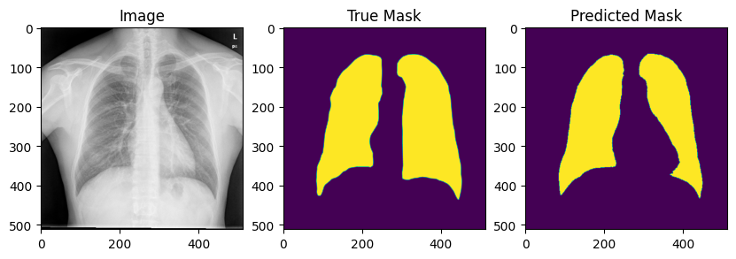

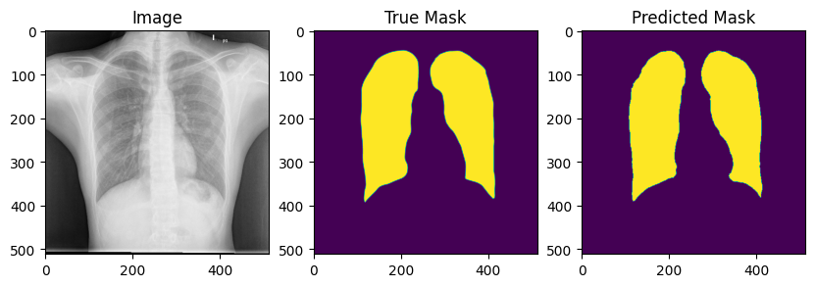

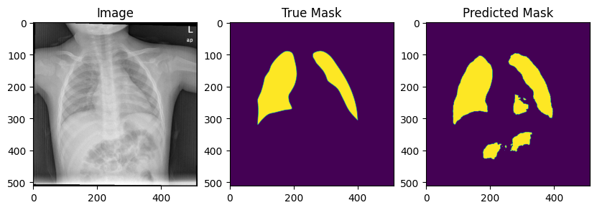

# **Batch size 4: LR rate = 0.01**

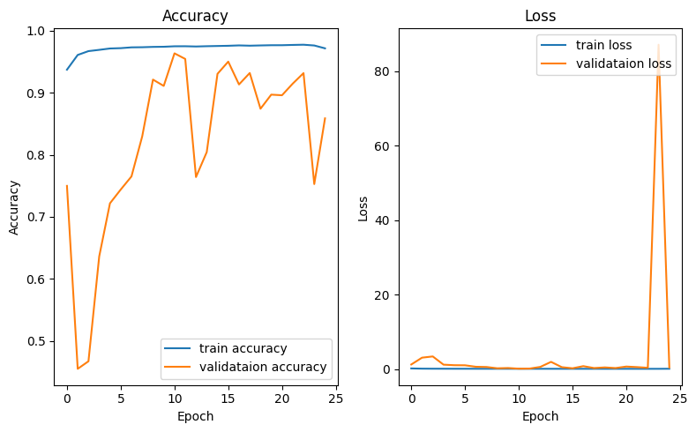

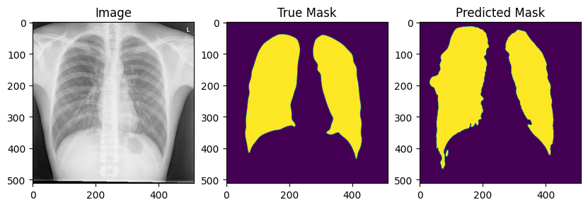

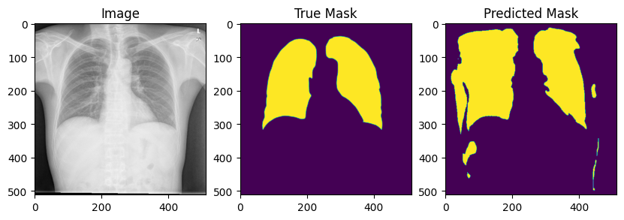  
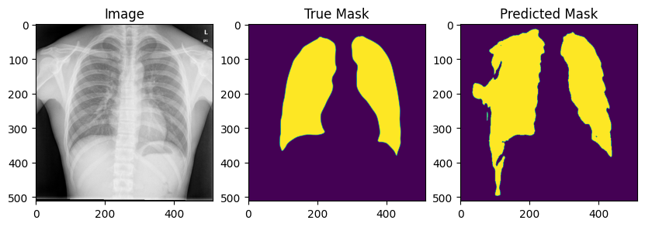

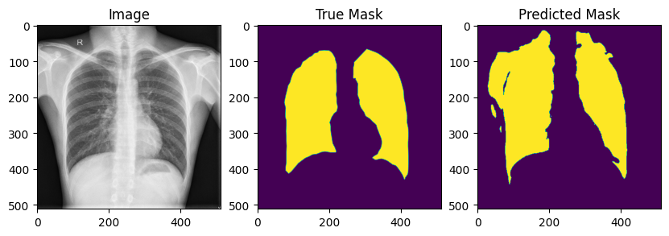

# **Batch size 4: LR rate = 0.0001**

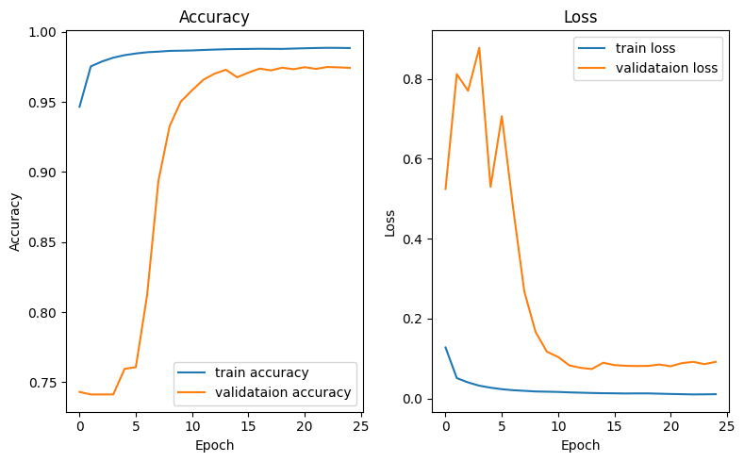

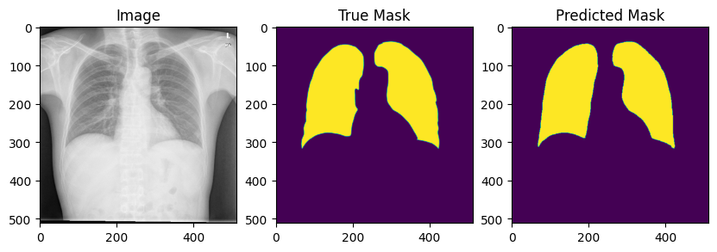

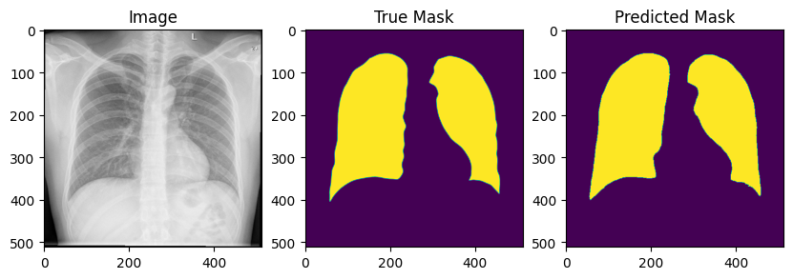

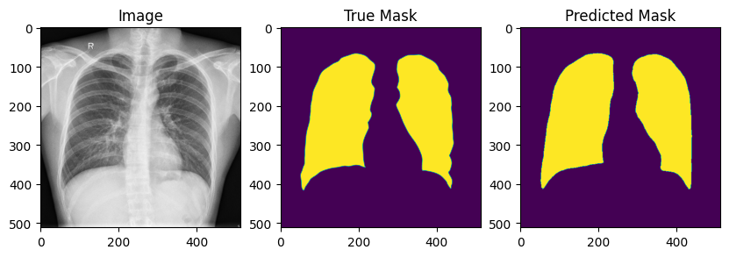

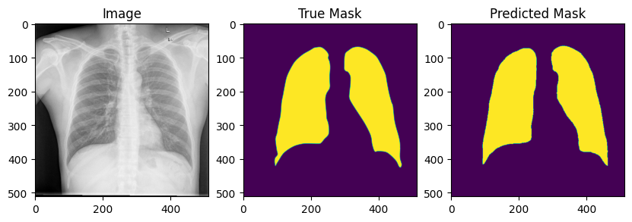

# **Batch size 4: LR rate = 0.001**

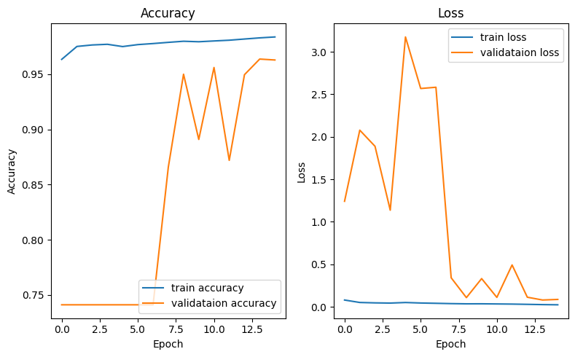

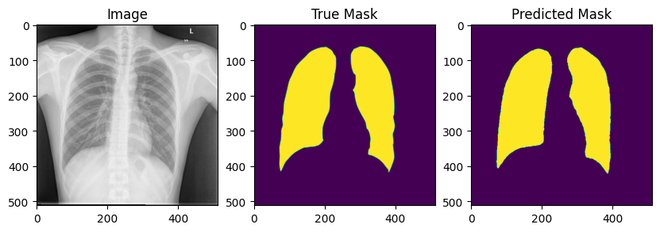 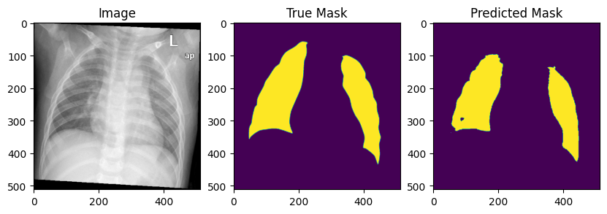

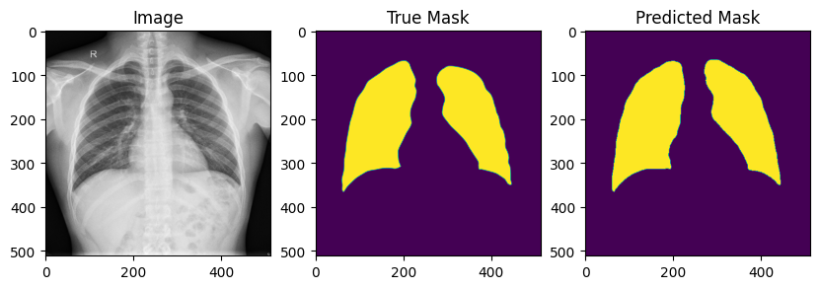

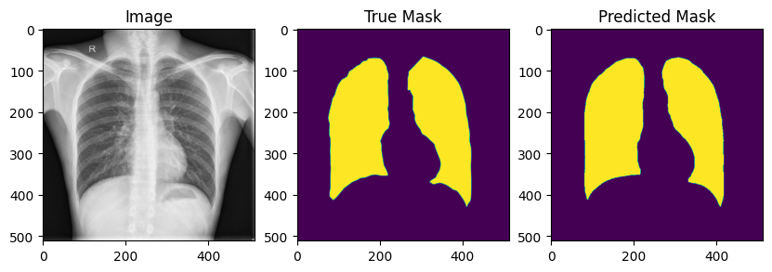

# **Batch size 16 - Learning Rate = 0.01 ,0.001 , 0.0001**

Epoch 1/25

---------------------------------------------------------------------------

ResourceExhaustedError Traceback (most recent call last)

[<ipython-input-22-f325bd6133a1>](https://localhost:8080/) in <cell line: 12>()

**10** EPOCHS = 25

**11**

---> 12 deeplab_model_history = deeplab_model.fit(train_dataset, epochs=EPOCHS,validation_data=val_dataset, callbacks=[checkpoint_callback])

1 frames

[/usr/local/lib/python3.10/dist-packages/tensorflow/python/eager/execute.py](https://localhost:8080/) in quick_execute(op_name, num_outputs, inputs, attrs, ctx, name)

**51** try:

**52** ctx.ensure_initialized()

---> 53 tensors = pywrap_tfe.TFE_Py_Execute(ctx._handle, device_name, op_name,

**54** inputs, attrs, num_outputs)

**55** except core._NotOkStatusException as e:

ResourceExhaustedError: Graph execution error:

Detected at node gradient_tape/model/conv2d_9/Conv2D/Conv2DBackpropFilter-0-TransposeNHWCToNCHW-LayoutOptimizer defined at (most recent call last):

<stack traces unavailable>

OOM when allocating tensor with shape[16,256,512,512] and type float on /job:localhost/replica:0/task:0/device:GPU:0 by allocator GPU_0_bfc

[[{{node gradient_tape/model/conv2d_9/Conv2D/Conv2DBackpropFilter-0-TransposeNHWCToNCHW-LayoutOptimizer}}]]

Hint: If you want to see a list of allocated tensors when OOM happens, add report_tensor_allocations_upon_oom to RunOptions for current allocation info. This isn't available when running in Eager mode.

[Op:__inference_train_function_26524]